Computing

Overview
Computing should be an innovative subject. ‘Computational thinking’ is a skill that children must be taught if they are to be ready for the workplace and able to participate effectively in this digital world. The skills, knowledge and principles that are applied within Computing allow children to become digitally literate and express themselves through technology.
With this in mind at Riverside Junior School we promise that each child will:
- Understand the importance of Online Safety in order to use technology respectfully and responsibly.
- Use computer programs effectively including the Internet and Microsoft Office, to prepare them for future work spaces.
- Become responsible and competent users of information and communication technology.
- Explore digital devices to design and create a range of programs, systems and art based projects.
- Use Espresso Coding to learn the principles of programming and control through design.

Competence

Learning basic computing skills is essential for development through Computing as a subject. We hope by providing children with the fundamental and core skills they need to become digitally literate they will be able to implement these in many different aspects throughout their lives. We believe that the more competent children become using technology, the more equipped and confident they will be exploring wider aspects of computing.

Our Curriculum Promise

Year 3 - How to use and apply basic computer skills, including keyboard and mouse control. As well as introducing the importance of Online Safety as a whole school approach, through specialist computing workshops and assemblies throughout the academic year. Children will also take part in our Internet Safety Week, which will encourage them to explore and manage their online identity, as well as understanding the importance of using the internet safely.

In Year 3, children will learn skills to benefit their computational thinking and technological knowledge, that they will be able to apply throughout their school experience. It is equally essential that we address the importance of Online Safety, due to the increasing number of children using technology from a young age.

Skills and knowledge

Within these lessons children will master:
- Mouse and keyboard control through BBC Bitesize ‘Dance Mat Touch Typing’ Level 1-4
- Access programs on a computer including Microsoft Office
- Games based around skill practice
- 6-week cycle of focussed Online Safety learning

Year 4 – How to use the program Microsoft Word, whilst applying skills learnt in year 3. As well as continuing to understand the importance of Online Safety, continued through our whole school approach and Internet Safety Week.

In Year 4, children will learn and explore Microsoft word as a program and follow the ‘Word for Windows Training’ which provides in depth explanations for key computing skills. In relation to applying these skills, children will create work linked with cross-curricular topics. https://support.office.com/en-gb/article/word-for-windows-training-7bcd85e6-2c3d-4c3c-a2a5-5ed8847eae73

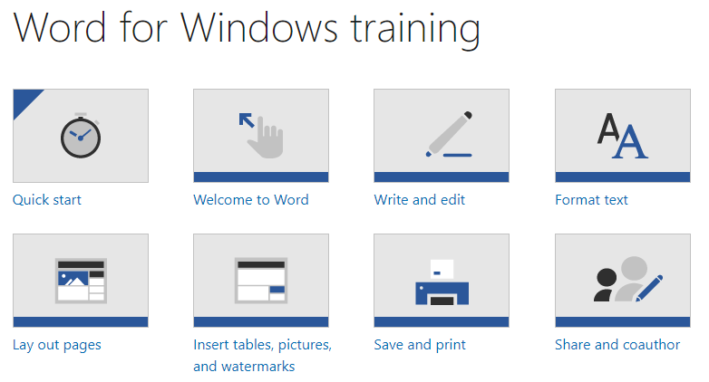

Skills and knowledge

Within these lessons children will master:
- Writing and editing
- Formatting text
- Inserting tables, pictures and shapes
- Saving and printing
- 6-week cycle of focussed Online Safety learning

Year 5 – How to use the program Power Point Presentation, whilst applying previous knowledge and skills. Online Safety focus program and workshops continued throughout the academic year.

In Year 5, children will build on the core foundations from previous years and the skills which they are now competent in. Children will learn and explore Microsoft PowerPoint as a program and follow the ‘PowerPoint for Windows Training’. In relation to applying these skills, children will create computing projects linked with cross-curricular topics. https://support.office.com/en-us/article/PowerPoint-for-Windows-training-40e8c930-cb0b-40d8-82c4-bd53d3398787

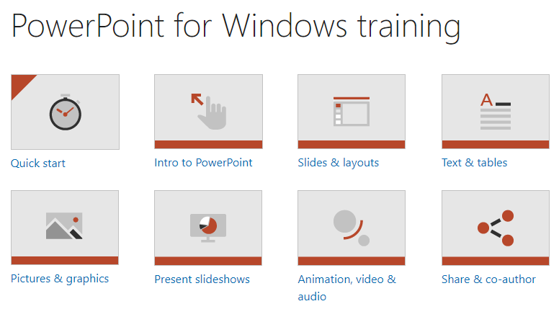

Skills and knowledge

Within these lessons children will learn how to:
- Slides, layouts and presenting
- Texts and tables
- Pictures and Graphics (building on design technology)
- Animation, video and audio
- 6-week cycle of focussed Online Safety learning

Year 6 – How to use the program Microsoft Excel and apply all previous computing skills learnt. Online Safety focus program continued, more specific to their age group.

In Year 6, children will build on their foundations from previous years to collect, analyse, evaluate and present data and information. Children will learn and explore the program Microsoft Excel by following the ‘Excel for Windows Training’. In relation to applying these skills, children will use the program with a cross curricular link to maths and statistics. https://support.office.com/en-us/article/excel-for-windows-training-9bc05390-e94c-46af-a5b3-d7c22f6990bb

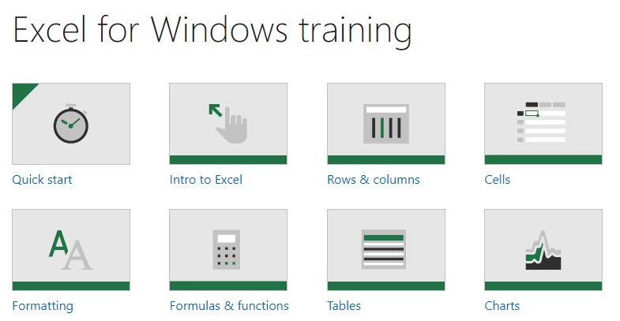

Skills and knowledge

Within these lessons children will learn how to:
- Rows and columns
- Cells and formatting
- Formulas and functions
- Tables and Charts
- 6-week cycle of focussed Online Safety learning

Creativity and Communication

Whilst at Riverside Junior School the children will have multiple opportunities to apply their computing skills through creative and communication based projects. They will be challenged with multiple design briefs, in order to explore a variety of software on a range of digital devices. Allowing pupils to express themselves online and explore their own creativity using a range of programs and systems.

Our Curriculum Promise

Year 3
- Create my own App design
- Explore the basics of self-portrait and history of photography.

In Year 3, children will be taught how to create their own App using ‘App Inventor’ http://www.appinventor.org/; which can be used for educational purposes and linked with any curriculum subject area. As well as exploring the history of photography and applying the self-portrait photography skills they have learnt to work towards making their own ‘Zoetrope’.

Skills and knowledge
- Understanding the purpose of programs including apps
- Using a combination of software and digital devices
- Exploring fundamental photography skills such as: holding a camera properly, focus, zoom, exposure.
- Manipulation of images in post-production

Year 4
- Design my own Stop-Start Animation
- Explore the world of Blogging and create my own.

In Year 4, children will explore the history of Stop-Start Animation and the process behind the production. They will learn the basics of animation design, to then apply this in their own project based learning using the ‘Stop Motion Studio’ program. Children will also explore the concept of ‘blogging’ and its purpose as well as benefits and will then create their own blogs based on worldwide topics which relate to other areas of the curriculum, using ‘KidBlog’. https://kidblog.org/home/

Skills and knowledge
- Apply coding skills learnt and apply these in the design process
- Learn key photography skills required for animation
- Explore the opportunities that communication and collaboration have to offer
- Use and combine a variety of software including internet services.

Year 5
- Design and create a podcast based around the theme of a Radio Station.
- Compose and program musical algorithms to play their own music (links with Music curriculum)

In Year 5, children will use software and digital devices for recording sound. Based around the theme of a Radio Station, it is designed to encourage a creative approach that includes interviewing, making adverts and using jingles. Using ‘I can Present’ or ‘IMovie’ software children will write scripts and design additional advertising for their podcast. Pupils will also engage in the BBC ‘Musical Micro:bit’ program, where they will compose musical phrases and apply their knowledge around algorithms, to create and play their own music. https://microbit.org/lessons/

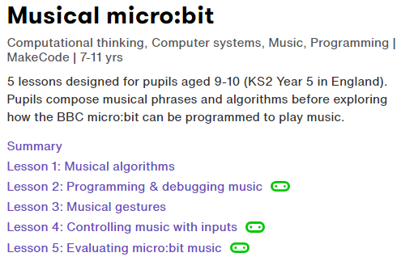

Skills and knowledge
- Explore sound software and recording
- Musical Algorithms
- Programming and debugging music
- Musical gestures
- Controlling music inputs and evaluating Micro:bit music

Year 6
- Create a 3D design of an original or new invention
- Apply Coding skills learnt to design a Webpage

In Year 6, children will apply all of the skills they have learnt throughout key stage 2 and become digitally literate. They will learn about different British inventors and explore the ‘significant turning points in British history’ (KS2 Nation Curriculum). In order to design a 3D computer based model of their own invention with a purpose for today’s society. Children will also transfer their knowledge from Year 4 blogging and skills from ‘Espresso Coding’ to design their own webpages for a retail company of their choice. Creating media – 3D Modelling (teachcomputing.org)

Skills and knowledge
- Learn about the history of British inventors throughout the years and how these impact our lives today.
- Express and develop their own ideas through information and communication technology.
- To understand how digital systems and programs work
- Apply HTML and Python knowledge and skills from ‘Espresso Coding’.

Coding

Coding itself accounts for half of the National Curriculum computing programme of study. At Riverside we have invested in a scheme which provides support for teaching coding throughout all year groups in primary schools. Discovery Education Coding helps teachers to deliver the following objectives in a fun and engaging way:

Espresso Coding provides step-by-step lessons for pupils to understand the fundamentals of coding through a sequence of video tutorials, whilst highlighting correct terminology. Debugging tasks and errors codes allow pupils to apply and improve their problem solving skills, as well as allowing pupils to be creative using the ‘free code’ function.

Block Coding - block coding lessons provide a graphical approach to coding where pupils drag and drop events, objects and actions to make things happen in a program, progressing to building their own games and apps. Block coding provides the key fundamentals for lower KS2.

HTML – allows children to discover how the web is built. Pupils will learn how web pages are designed, structured and presented with HTML mark-up and CSS. They’ll add tags, images, and links to bring their web pages to life.

Python – children explore how this real-life coding language works. Pupils will learn how to write programs using text, and apply their coding know-how to build quizzes, draw graphics and run simulations.

Key Stage 2 – Coding National Curriculum

- Design and write programs that accomplish specific goals, including controlling or simulating physical systems; solve problems by decomposing them into smaller parts.
- Use sequence, selection, and repetition in programs; work with variables and various forms of input and output; generate appropriate inputs and predicted outputs to test programs.
- Use logical reasoning to explain how a simple algorithm works and to detect and correct errors in algorithms and programs.

Online Safety

Our aim at Riverside is to ensure that all children are equipped with the skills to use technology safely, respectfully and responsibly. Children will recognise acceptable and unacceptable behaviour when using the internet, whilst identifying a range of ways to report concerns about content and contact they may encounter. Children will participate in our whole school Anti-Bullying week and Safer Internet Day throughout the academic year; where they will undertake a range of activities to widen their knowledge and understanding about the importance of Online Safety.

Skills and knowledge

Year 3

- Children will review and edit our current online safety rules in school.
- Developing an awareness of online bullying.
- Assessing the trustworthiness of websites.
- Understanding our digital footprint and the digital trails we leave behind.
- Practising good netiquette
- Children discover that online identities may be misleading or false.

Year 4

- Reviewing and editing our online safety rules.
- Dealing positively with peer pressure.
- Children compare and contrast the ways messages were sent before and after the advent of the internet.
- Understanding risk and prevention of information loss.
- Understanding and respecting digital rights and responsibilities.
- Virtual friendship vs real friendship and who we can trust online.

Year 5

- Reviewing and editing our online safety rules.
- Understanding the impact of online behaviour.
- Understanding advertising and endorsements online.
- Developing strategies to protect our future selves.
- Understanding and applying copyright laws.
- Understanding how game developers make money.

Year 6

- Reviewing and editing our online safety rules
- Understanding inappropriate use of technology and the internet.
- Children learn that most popular networking sites have age restrictions which should be adhered to.
- Respecting the personal information and privacy of others.
- Children will develop confidence in responding to unfamiliar online safety scenarios, in preparation for moving on to secondary education.
- Creating and delivering advice on safe online gaming.

Curriculum Overview – Half Terms

