History

Overview
Here at Riverside, we believe that a rich, high quality history education will provide our pupils with a coherent and powerful knowledge of Britain’s fascinating past and that of the wider world. We want our curriculum to capture children’s curiosity and equip them to ask perceptive questions, think critically, weigh evidence, sift arguments, and develop perspective and judgement. Studying History is vital because it allows us to understand our past, which in turn allows us to understand our present and who we can be in our future. Ultimately, History provides understanding of what makes us who we are. Through our teaching, we aim for our children to leave Riverside as unprejudiced, intuitive individuals who are able to learn from mistakes, understand people better and, as a result, become more compassionate as people and more impartial as decision makers.

Key Stage 2

Pupils in Key stage 2 need to experience history as a coherent subject which develops their knowledge, thinking and understanding, especially their chronological understanding. It is essential that children establish clear, chronological narratives within and across their periods of study and should note connections, contrasts and trends over time, devising and answering historically valid questions about change, cause, similarity and difference, and significance.
With this in mind at Riverside Junior School we promise that each child will:
- Have topics delivered to them in chronological order to support their coherent narrative, from the earliest times to the present day.
- Learn how people’s actions have shaped this nation and how Britain has influenced and been influenced by the wider world.
- Know and understand significant aspects of the history of the wider world developing their ability to appreciate cultures, ideas, and traditions that are not their own.
- Learn through project based learning with rich, meaningful outcomes.
- Be provided with resources to support them in constructing informed responses that involve thoughtful selection and organisation of relevant historical information.
- Perceive how our knowledge of the past is constructed from a range of sources.
- Understand the methods of historical enquiry, including how evidence is used rigorously to make historical claims, and discern how and why contrasting arguments and interpretations of the past have been constructed.
- Gain historical perspective by placing their growing knowledge into different contexts.
- Acquire and deploy rich, historical vocabulary.

Project Based learning

At Riverside, our historical expertise is mostly acquired through Project Based Learning. This is a teaching method in which students gain knowledge and skills by working for an extended period of time to investigate and respond to an authentic, engaging and complex ‘key question’ broken down in to smaller enquiry questions. We believe that pupils who engage in this type of learning retain content longer and have a much deeper understanding of what they’re learning. The approach also helps students master important 21st century skills like problem solving, critical thinking, conflict resolution and teamwork. It is our role as teachers, to guide and facilitate our children through the process with effective resourcing and questioning; ultimately supporting their creative and critical thinking to take their learning where they desire for it to go.

Thematic Approach

Studies are clear about the need to link learning within and across year groups. This requires imaginative work yet, at Riverside, we find that overarching themes have a hugely positive impact and open many doors.
Our year is split in to three themes:
- Our Ancient World (Term 1)
- British History (Term 2)
- How History Has Shaped Us (Term 3)
This approach aims to instigate flow of conversations across year groups, employing an intergenerational approach where students can learn from each other and begin to form their own lines of interest and discovery. It will also be a tool that encourages wider thinking and children can begin to understand the patterns that plays across history. This will allow them to understand the similarities of different cultures, eras and people and see that we are more alike than we are different to be at the forefront of their learning. Ultimately, bringing a real sense of collaboration and unity across the school.

Term 1A

Theme – Our Ancient World

Children are naturally curious, and what is more interesting than the ancient belief systems that so many of our peers and ancestors have dedicated their lives to? By teaching them about the world’s historic religions and beliefs, we are giving them opportunity to develop respect for others, regardless of their beliefs, race or social status. In our diverse society, children need an understanding of other principal religions and other world views.

Year 3 – Ancient Egypt

Key Question - What was the significance of Ancient Egyptian beliefs?

In Year 3, children will have an introduction to Ancient Egypt looking at aspects of daily life such as clothing, education and farming. They will then move on to answering their key question through project based learning and enquiry questions focussing on these areas:
What made the Nile sacred to the Ancient Egyptians? | What role did pharaohs play in Ancient Egypt? | Why were the pyramids built?
What was the purpose of canopic jars? | What was the process of mummification? | What gods did the Ancient Egyptians believe in?

At the end of each topic, we will look at how this particular historical period compares to modern day and what its impact has been.

Year 4 – Ancient Maya

Key Question - What was the significance of Mayan beliefs?

In Year 4, children will have an introduction to The Maya looking at aspects of daily life such as clothing, food, homes, education and entertainment. They will then move on to answering their key question through project based learning and enquiry questions focussing on these areas:
Which gods did the Mayans believe in? | What role did the Divine Kings play? | How were priests involved in rituals?
What was the journey through the underworld like? | Why was the Mayan calendar significant? | Why were pyramids important to the Mayans?

At the end of each topic, we will look at how this particular historical period compares to modern day and what its impact has been.
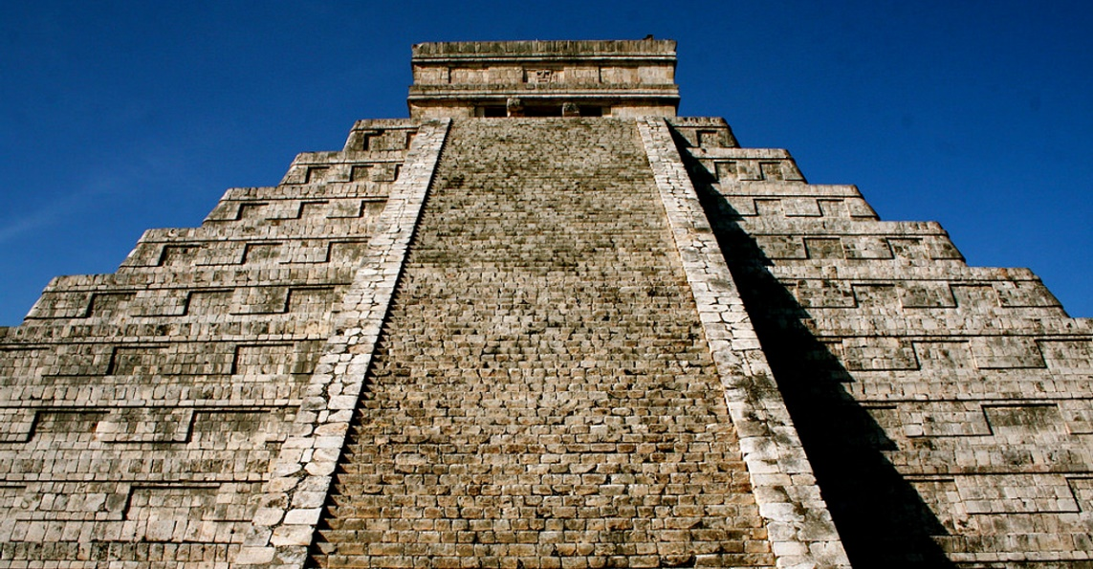

Year 5 – Ancient Sumer

Key Question - What was the significance of Ancient Sumer beliefs?

In Year 5, children will have an introduction to the Ancient Sumer looking at aspects of daily life and will touch on impressive innovations including irrigation, writing, mathematics, astronomy and architecture. They will then move on to answering their key question through project based learning and enquiry questions focussing on these areas:
What do Sumerians believe about Eridu? | How important were gods to Sumerians? | Who were the religious leaders of the Sumerians?
Why is The Epic of Gilgamesh so symbolic? | What was the significance of ziggurats? | Who went to the World of the dead?

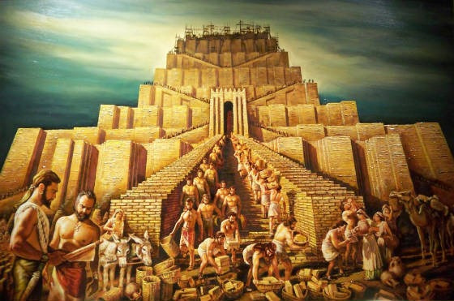
At the end of each topic, we will look at how this particular historical period compares to modern day and what its impact has been.

Year 6 – Ancient Greece

Key Question - What was the significance of Ancient Greek beliefs?

In Year 6, children will have an introduction to the Ancient Greeks looking at aspects of daily life and will touch on the Greek legacy such as trial by jury, democracy, theatre and the Olympics! They will then move on to answering their key question through project based learning and enquiry questions focussing on these areas:
What was the purpose of temples in Ancient Greece? | Who was the most powerful Greek god? | What was the significance of Mount Olympus?
How did Greek religion affect daily life? | What were the Olympia Games held in honour of? | Why were festivals important in ancient Greece?

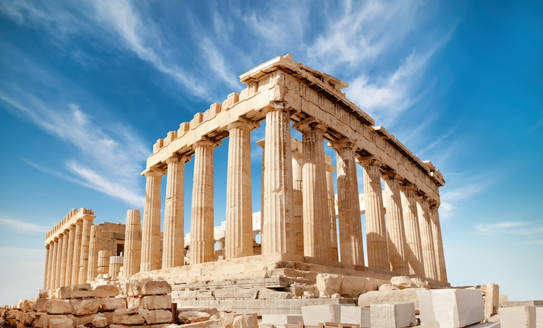
At the end of each topic, we will look at how this particular historical period compares to modern day and what its impact has been.

Term 2A

Theme – British History

Historical movements of armies in to regions, which have been part of a war or conflict, have had huge impacts on the world we live in today. Learning about significant invasions and the mass change they brought with them is critical for children to engage with as looking deeper into these past moments enables them to see present developments in a new light and to ponder the complex decisions that have led to major turning points in history.

Year 3 – The Romans

Key Question - What impact did Caesar’s invasion have on Britain?

In Year 3, children be introduced to The Romans looking at the impact these trend setters had and what things in modern Britain we owe to the influence of the Roman Empire. They will answer their key question through project based learning and enquiry questions focussing on these areas:
What role did Julius Caesar play in the Roman conquest of Britain? | Why was the Roman army so successful? | What was life like as a Roman?
What is the significance of Hadrian’s wall? | Why did the Romans build roads? | How did the Romans change towns?

At the end of each topic, we will look at how this particular historical period compares to modern day and what its impact has been.

Year 4 – The Anglo Saxons

Key Question - What changes did the Anglo Saxons bring to Britain?

In Year 4, children will have an introduction to The Anglo Saxons focussing on their different way of life in the aftermath of the Romans’ departure. They will answer their key question through project based learning and enquiry questions focussing on these areas:
Where did the Angle, Saxon and Jute tribes come from? | What were the Anglo Saxon kingdoms? | How did Anglo Saxons build their houses?
What was life like for an Anglo Saxon? | What did Alfred The Great accomplish? | What is the significance of the Battle of Hastings?

At the end of each topic, we will look at how this particular historical period compares to modern day and what its impact has been.
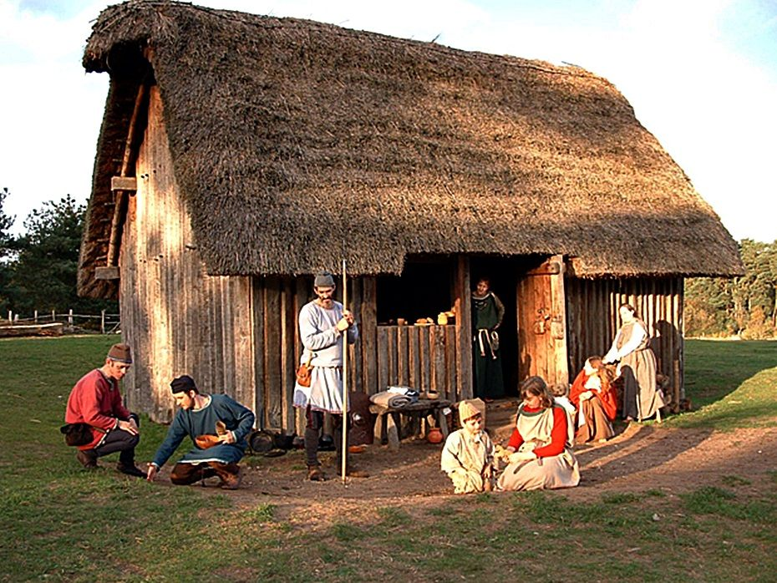

Year 5 – The Vikings

Key Question - What was the impact of the Viking invasions on Britain?

In Year 5, children will be introduced to the Vikings looking at the effects their persistent invasions had on the life of the Anglo Saxons. They will then move on to answering their key question through project based learning and enquiry questions focussing on these areas:
Why was Lindisfarne Attack so significant? | What did the result of the Battle of Edington mean for the Vikings? | Where did Vikings settle?
Why was Jorvik important to the Vikings? | How is Cnut the Great remembered? | What was life like as a Viking?

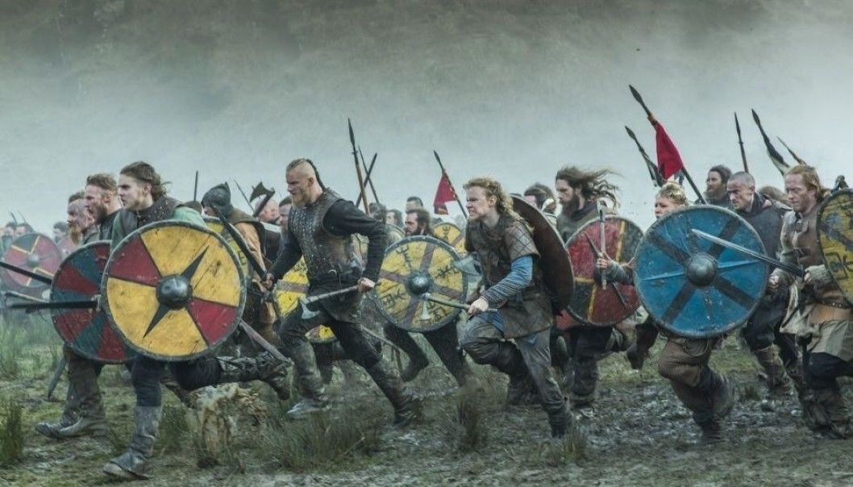
At the end of each topic, we will look at how this particular historical period compares to modern day and what its impact has been.

Year 6 – WW2

Key Question - What impact did WW2 have on Britain?

In Year 6, children will study the six years from 1939 to 1945 where Britain fought the toughest war it had ever experienced and how it changed the World. They will then move on to answering their key question through project based learning and enquiry questions focussing on these areas:
What was Adolf Hitler’s master plan? | How did evacuation affect people’s lives in WW2? | What was the significance of the Blitz?
Why were there campaigns during the war? | What were the roles of women in WW2? | Why is VE day important?

At the end of each topic, we will look at how this particular historical period compares to modern day and what its impact has been.
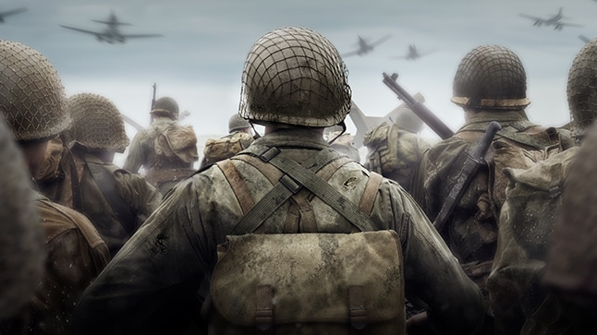

Term 3A

Theme – How Has History Shaped Us?

History helps one to understand the immense complexity of our world and therefore enables one to cope with the problems and possibilities of the present and future. This half term, children will develop a sense of their collective past including studying events and people who have made us who we are today.

In today’s world, the impact of role models is so important and giving children the opportunity to learn about women in history who have made a difference is essential. Delving deeper in to pains and victories of our ancestors will provide children with a developed appreciation, not only for the accomplishments but also the adversity of the people (of all races and genders) who have dared to make a change.

Year 3 – Stone Age – TBC.

Key Question - What can we learn from The Stone Age?

Year 4 – Inspirational Women

Key Question – Which historical women have made a difference?
Emmeline Pankhurst  Could women always vote? | What inspired Frida Kahlo? | How did Rosa Parks make a change?
Mary Anning  What did Mary Anning dicover? | Mother Teresa  Why is Mother Teresa a hero? | Amelia Earhart  What did Amelia Earhart accomplish?

In Year 4, children will take a look back at the achievements of some women who have well and truly left their mark on history through amazing things that they have done. They will answer their key question through project based learning and enquiry questions focussing on these areas:

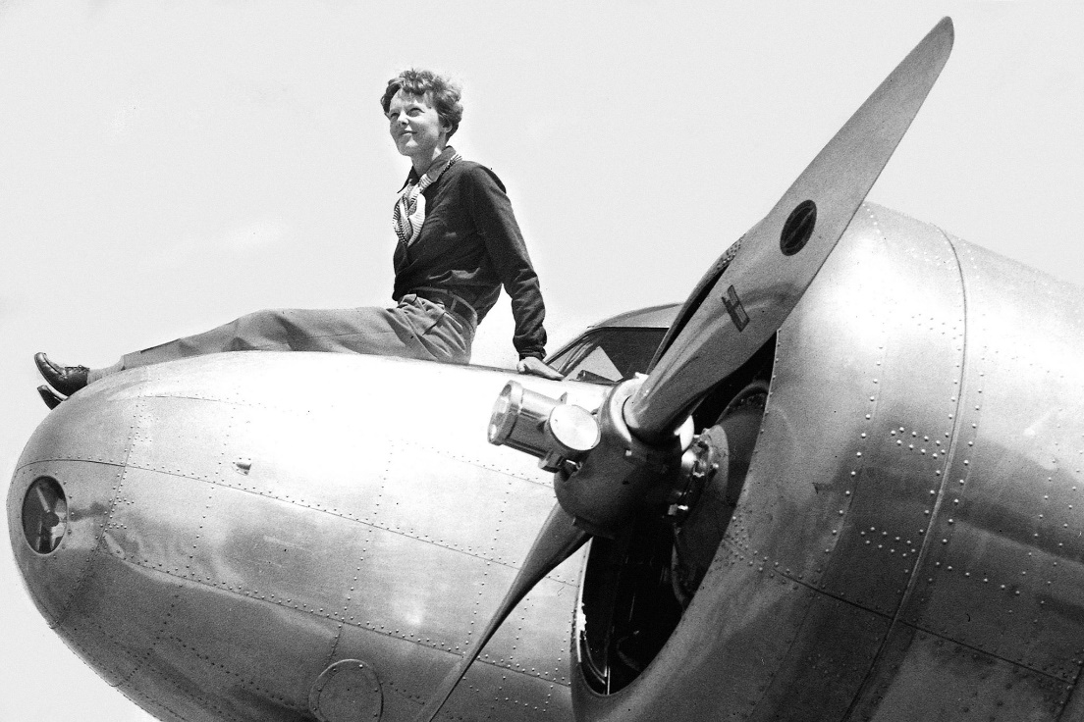
At the end of each topic, we will look at how this particular historical period compares to modern day and what its impact has been.

Year 5 – The Victorians

Key Question - What was the significance of Queen Victoria?

In Year 5, children will study a time of tremendous change in the lives of British people under the reign of Queen Victoria. They will answer their key question through project based learning and enquiry questions focussing on these areas:
What was Queen Victoria famous for? | What was it like to be a child living in Victorian Britain? | What were factory conditions like ?
What was the industrial Revolution? | What the Victorians invent? | What was the fastest way to travel in Victorian times?

At the end of each topic, we will look at how this particular historical period compares to modern day and what its impact has been.
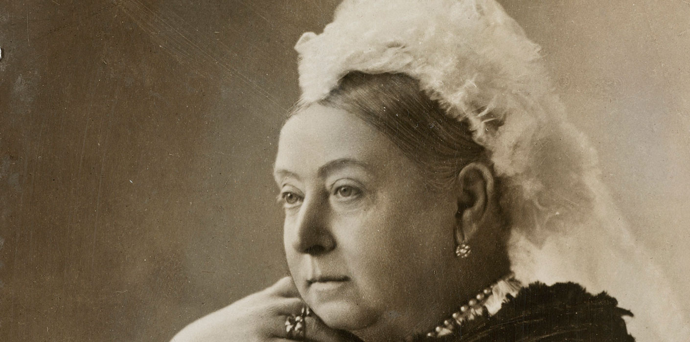

Year 6 – Our Local area

Key Question - What is the story of our town?

In Year 6, children will look at our local area. The history of Hebden Bridge is fascinating and moving. It was our Pennine hills and valleys which powered the mills and factories of the first Industrial Revolution - the overgrown ruins of these old mills can still be seen in many of our valleys. Children will study the unique history of our local area including learning about significant figures and their stories that are still told today. They will answer their key question through project based learning and enquiry questions focussing on these areas:
Why was Hebden Bridge known as ‘Trouser Town’? | What is the history of Hebden Bridge Cinema? | Where is Sylvia Plath buried?
When did the Piece Hall open? | Who was Anne Lister? | Why are the Bronte sisters famous?

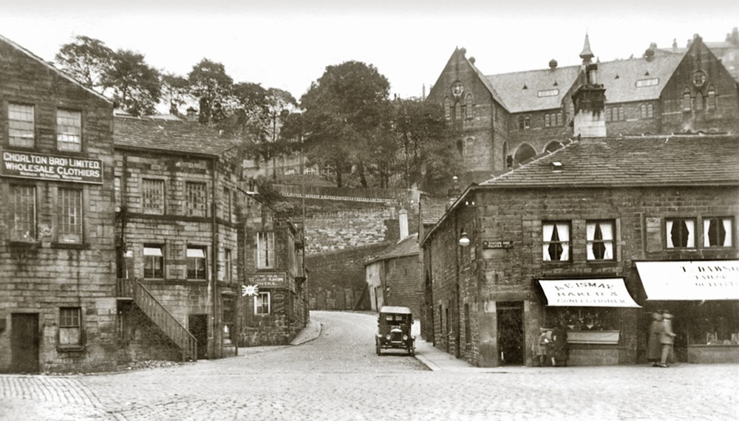
At the end of each topic, we will look at how this particular historical period compares to modern day and what its impact has been.

Theme Map

Term 1A | Year 3 – Ancient Egypt | Year 4 – Ancient Maya | Year 5 – Ancient Sumer | Year 6 – Ancient Greece
Theme – Our Ancient World | Key Question – What was the significance of Ancient Egyptian beliefs? | Key Question - What was the significance of Mayan beliefs? | Key Question - What was the significance of Ancient Sumer beliefs? | Key Question - What was the significance of Ancient Greek beliefs?
Term 2A | Year 3 – The Romans | Year 4 – The Anglo Saxons | Year 5 – The Vikings | Year 6 – WW2
Theme – British History | Key Question - What impact did Caesar’s invasion have on Britain? | Key Question - What changes did the Anglo Saxons bring to Britain? | Key Question - What was the impact of the Viking invasions on Britain? | Key Question - What impact did WW2 have on Britain?
Term 3A | Year 3 – The Stone Age | Year 4 – Significant Figures | Year 5 – The Victorians | Year 6 – Our Local Area
Theme – How Has History Shaped Us? | Key Question - What can we learn from The Stone Age? | Key Question – Which historical women have made a difference? | Key Question - What was the significance of Queen Victoria? | Key Question - What is the story of our town?

Enrichment Experiences

Year 3
Term 1A - Ancient Egypt
Leeds Museum - https://museumsandgalleries.leeds.gov.uk/workshop-item/ancient-worlds-ancient-egyptians/
York Museum - https://www.yorkmuseumstrust.org.uk/education/schools-2-2/workshop-programme-yorkshire-museum/
Term 2A – The Romans
Murton Park - http://www.murtonpark.co.uk/roman/
Term 3A – The Stone Age
Stone Age workshop -https://www.educationgroup.co.uk/workshops/stone-age-life
Herd Farm https://www.herdfarm.co.uk/schools/iron-age-houses
Murton Park - http://www.murtonpark.co.uk/stone-agebronze-age/

Year 4
Term 1A – Ancient Maya
Workshop -https://mayaarchaeologist.co.uk/teachers/workshops-for-pupils/
Term 2A – The Anglo Saxons
Rydale Folk Museum - https://www.ryedalefolkmuseum.co.uk/learning/
Term 3A – Significant Figures

Year 5
Term 1A – Ancient Sumer
Term 2A – The Vikings
Yorvik Viking Musuem - https://www.jorvikvikingcentre.co.uk/
Term 3A – The Victorians
Bankfield Museum Workshop –http://museums.calderdale.gov.uk/visit/bankfield-museum

Year 6
Term 1A – Ancient Greece
Ancient Greek interactive workshop – Sheffield https://www.museums-sheffield.org.uk/learning/schools-and-colleges/workshops/athena-2012
Ancient Greek workshop in school - https://www.portalstothepast.co.uk/classes/ks2-ancient-greeks/
Ancient Greek interactive workshop– York Museum https://www.yorkmuseumstrust.org.uk/education/schools-2-2/workshop-programme-yorkshire-museum/
Term 2A – WW2
Eden Camp - https://www.edencamp.co.uk
Term 3A – Our local area
Shibden Hall – Anne Lister – https://museums.calderdale.gov.uk/visit/shibden-hall
Bankfield Museum – Story of Halifax and Calderdale http://museums.calderdale.gov.uk/visit/bankfield-museum
Industrial Museum Bradford – Links to history of the mills in Hebden Bridge - https://www.bradfordmuseums.org/venues/bradford-industrial-museum
Canal Cruises/history of the canal - http://hebdenbridgecruises.com/en/top/school-trips/
Local history treasure hunt and mill talk - http://www.huntfun.co.uk/fun-treasure-hunt-things-to-do/Hebden.php?rfl=0000

Next steps:

- Enrichment experiences to be attached at the end of every topic.
- Staff meeting in September to discuss:
- Implementation and measuring impact.
- Implementation of BLM/WOMEN.
- Retaining and recalling info in regards to coherent, chronological narrative and how we will ensure they are exposed to opportunities – Assemblies/timelines around school/memory boxes/quizzes/stories.
- Making the most of Project Based Learning - Riverside Museum in the hall focussing on their theme that half term. Chn can be involved in discussions looking at similarities and differences between the different topics they have been studying. Can dress up and be in role – opportunities to really promote discussions?

