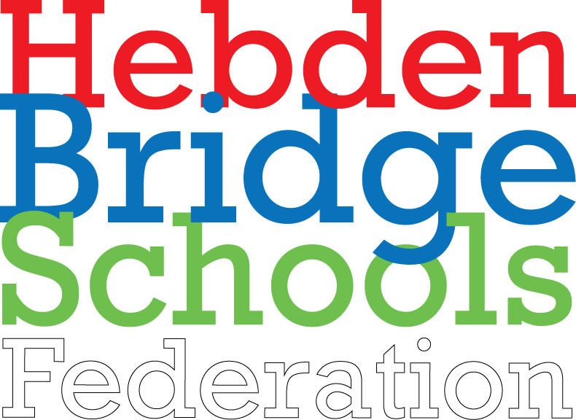

Pupil Premium Policy
2022 - 2024

Overview
The Pupil Premium was introduced in April 2011 and paid by means of a specific grant based on school census figures for pupils registered as eligible for Free School Meals in reception to Year 11. For looked after children the Pupil Premium was calculated using the Children Looked After data returns (SSDA903). A premium has also been introduced for children whose parents are currently serving in the armed forces. This service premium is designed to address the emotional and social well-being of these pupils. The Pupil Premium is additional to main school funding and it will be used by this school to address any underlying inequalities between children eligible by ensuring that funding reaches the pupils who have been identified as within the Pupil Premium Category.
Objectives
• The Pupil Premium will be used to provide additional educational support to improve the progress and to raise the standard of achievement for these pupils
• The funding will be used to narrow and close the gap between the attainment and achievement of these pupils and their peers
• The school will use the additional funding to address any underlying inequalities between children eligible for Pupils Premium and others
• We will ensure that the additional funding reaches the pupils who have been identified as within the Pupil Premium category and that it makes a significant impact on their education and lives.
Strategies
• Pupil Premium income will be clearly identifiable within the budget.
• The Head teacher in consultation with the governors and staff, will decide how the Pupil Premium is spent for the benefit of entitled pupils.
• The school will assess what additional provision should be made for the individual pupils.
• The school will be accountable for how it has used the additional funding to support the achievement of those pupils covered by the Pupil Premium and the Head teacher will report to the governing body and parents on how effective the intervention has been in achieving its aims.
• We will publish online information about how we have used the Premium.
• We will ensure that parents, governors and others are made fully aware of the attainment and achievement of pupils covered by the Premium.
• Pupil Premium may be used to provide additional adult support, purchase resources, provide appropriate training for staff and create additional experiences and opportunities for targeted pupils.
• We will seek to further develop strategies and interventions which can improve the progress, attainment and achievement of these pupils.
• We will track the impact of the strategies put into place through the funding to ensure that we can show the value that has been added to the education of the entitled children.
• We will monitor evaluate and review the success of the impact of the pupil premium funding.

Outcomes
• This policy will play an important part in the educational development of the individual pupils who are entitled to the Pupil Premium.
• We will ensure that these pupils are treated equally and as favourably as others and that the additional funding is used well to address the challenges they face.
• The school will use the additional funding to promote the achievement and progress of all entitled pupils.
• Through targeted use of this additional funding we are fully committed to ensuring that the individual needs of each entitled child are met.
• As a result of the additional funding, and opportunities this will provide, we aim that these children will make better progress and achieve higher standards.
Equal Opportunities
The school is committed to providing equal opportunities for all, regardless of race, faith, gender or capability in all aspects of school. We promote self and mutual respect and a caring and non-judgmental attitude throughout the school.
This policy will be reviewed every 2 years

September 2022

