Riverside Junior School Calculation Policy
At Riverside we have adapted the White Rose Maths scheme of learning to teach as we feel appropriate through a small steps approach. We aim to emphasise on physical and visual representations, offering children the best foundation to building a core mathematical understanding.

Place Value and Number
Key Language: part-whole, digit, value, ones/tens/hundreds/thousands, estimate, round

Part-Whole Model | The part-whole model supports children in their understanding of partitioning.  When the parts are complete the whole is empty, children use aggregation to add the parts together to find the total.  When the whole is complete and at least one of the parts is empty, children use partitioning (a form of subtraction) to find the missing part.  Part-whole models can be used to partition a number into two or more parts, or to help children to partition a number into tens and ones or other place value columns.  In KS2, children can apply their understanding of the part-whole model to add and subtract fractions, decimals and percentages. | 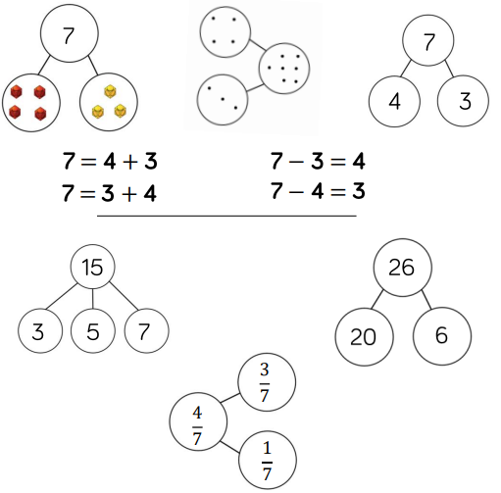
Bar Model | The single bar model is another type of a part-whole model that can support children in representing calculations to help them unpick the structure. Cubes and counters can also be used in a line as a Concrete representation of the bar model.  Discrete bar models are a good starting point with smaller numbers. Each box represents one whole.  The Combination bar model can support children to calculate by counting on from the larger number It is a good stepping stone towards the continuous bar model.  Continuous bar models are useful for a range of values. Each rectangle represents a number. The question mark indicates the value to be found. In KS2, children can use bar models to present larger numbers, decimals and fractions.  Children can use the single bar model to represent multiplication as repeated addition. They could use counters, cubes or dots within the bar model to support calculation before moving on to placing digits into the bar model to represent the multiplication.  Division can be represented by showing the total of the bar model and then dividing the bar model into equal groups. It is important when solving word problems that the bar model represents the problem.  Sometimes, children may look at scaling problems. In this case, more than one bar model is useful to represent this type of problem. E.g. There are 3 girls in a group. There are 5 times more boys than girls. How many boys are there? The multiple bar model provides an opportunity to compare the groups. | 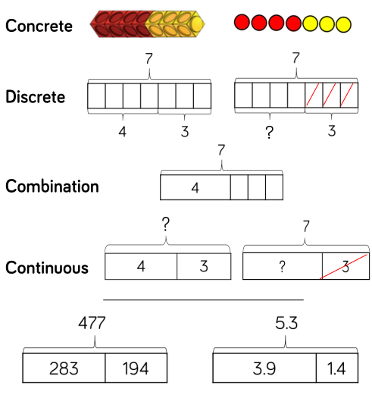  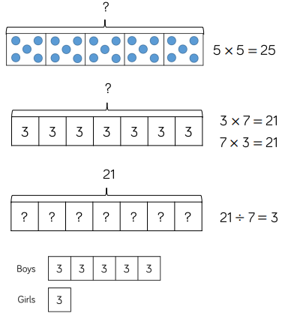
Ten Frames (within 10) | When adding and subtracting within 10, the ten frame can support children to understand the different structures of addition and subtraction.  Using the language of parts and wholes represented by objects on the ten frame introduces children to partitioning and aggregation. Aggregation is a form of addition where parts are combined together to make a whole. Partitioning is a form of subtraction where the whole is split into parts. Using these structures, the ten frame can enable children to find all the number bonds for a number.  Children can also use ten frames to look at augmentation (increasing a number) and take-away (decreasing a number). This can be introduced through a first, then, now structure which shows the change in a number in the ‘then’ stage. This can be put into a story structure to help children understand the change e.g. First, there were 7 cards. Then, 3 cars left. Now, there are 4 cards. | 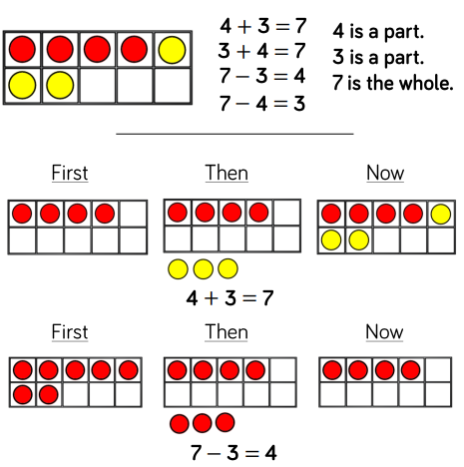
Number Tracks | Number tracks are useful to support children in their understanding of augmentation and reduction.  When adding, children count on to find the total of the numbers. On a number track, children can place a counter on the starting number and then count on to find the total.  When subtracting, children count back to find their answer. They start at the minuend and then takeaway the subtrahend to find the difference between the numbers.  Number tracks can work well alongside ten frames which can also model counting on or counting back. Playing board games can help children become familiar with the idea of counting on using a number track before they move onto number lines.  Numbers tracks are useful to support children to count in multiples, forwards and backwards. Moving counters or cubes along the number track can support children to keep track of their counting. When multiplying children place their counter on 0 to start and then count on to find the product of the numbers.  When dividing, children place their counter on the number they are dividing and they count back in jumps of the number they are dividing by until they reach 0. Children record how many jumps they have made to find the answer to the division. Number tracks can be useful with smaller multiples but when reaching larger numbers they can become less efficient and a written method will need to be used. | 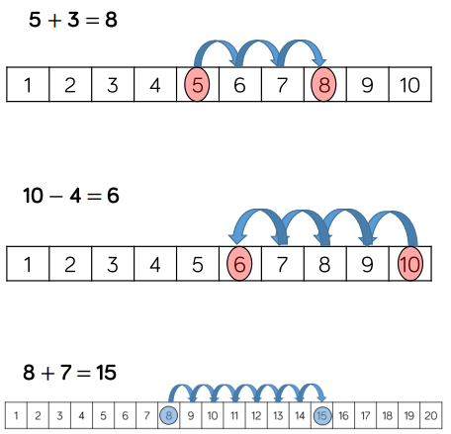  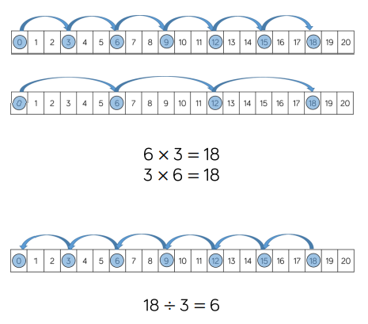
Number Lines | Labelled number lines support children in their understanding of addition and subtraction as augmentation and reduction.  Children can start by counting on or back in ones, up or down the number line. This skill links directly to the use of the number track.  Progressing further, children can add numbers by jumping to the nearest 10 and then jumping to the total. This links to the making 10 method which can also be supported by ten frames. The smaller number is partitioned to support children to make a number bond to 10 and to then add on the remaining part.  Children can subtract numbers by firstly jumping to the nearest 10. Again, this can be supported by ten frames so children can see how they partition the small number into two separate jumps.  Blank number lines provide children with a structure to add and subtract numbers in smaller parts. Developing from labelled number lines, blank number lines can also be used effectively to help children subtract by finding the difference between numbers.  Children can use blank number lines to represent scaling as multiplication and division. Blank number lies with intervals can support children to represent scaling accurately. Children can label intervals with multiples to calculate scaling problems. Blank number lines without intervals can also be used for children to represent scaling. | 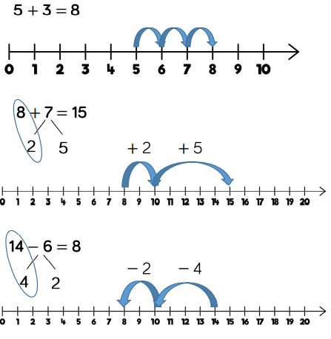  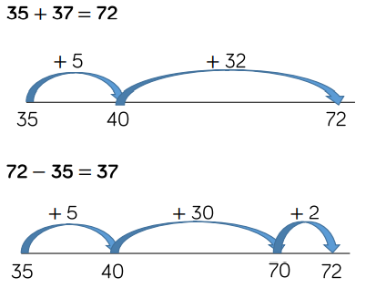  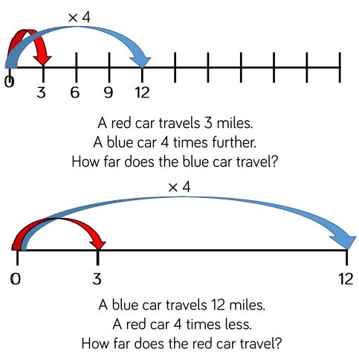
Base 10 | Addition  Using Base 10 is an effective way to support children’s understanding of column addition. It is important that children write out their calculations alongside using or drawing Base 10 so they can see the clear links between the written method and the model.  Children should first add without exchanging before moving on to addition with exchange. The representation becomes less efficient with larger numbers due to the size of the Base 10. In this case, place value counters may be the better model to use.  When adding, always start with the smallest Place value column (Ones). Here are some questions to support children:  - Can we make an exchange?  - How many do we exchange?  - How many Ones do we have left?  Subtraction  Using Base 10 is also an effective way to support children’s understanding of column subtraction. Children should first subtract without an exchange before moving on to subtraction with exchanging. When building the model, children should just make the minuend using Base 10 they then subtract the subtrahend. Highlight this difference to addition to avoid errors by making both numbers.  Children start with the smallest place value column. When there are not enough ones/tens/hundreds to subtract in a column, children need to move to the column to the left and exchange e.g. exchange 1 ten for 10 ones. They can then subtract efficiently.  This model is efficient with up to 4-digit numbers. Place value counters are more effective with larger numbers and decimals.  Multiplication  Using Base 10 is an effective way to support children’s understanding of column multiplication. It is important that children write out their calculation alongside the equipment so they can see how the concrete and written representations match.  As numbers become larger in multiplication or the amounts of groups becomes higher, Base 10 becomes less efficient due to the amount of equipment and number of exchanges needed.  Base 10 also supports the area model of multiplication well. Children use the equipment to build the number in a rectangular shape which they then find the area of by calculating the total value of the pieces. This grid method can be used alongside a formal column method of multiplying 2-digits by 2-digits.  Division  Using Base 10 is an effective way to support children’s understanding of division. When numbers become larger, it can be an effective way to move children from representing numbers as ones towards representing them as tens and ones in order to divide. Children can share the Base 10 between different groups e.g. by drawing circles or by rows on a place value grid.  When they are sharing, children start with the larger place value and work from left to right. If there are any left in a column, they exchange e.g. one ten for ten ones. When recording, encourage children to use the part-whole model so they can consider how the number has been partitioned in order to divide. They will support them with mental methods. | 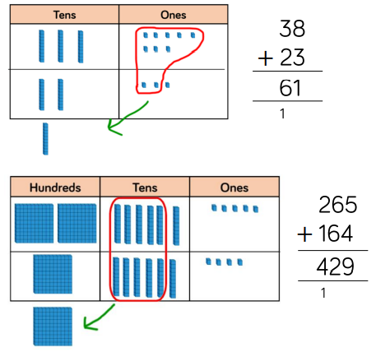  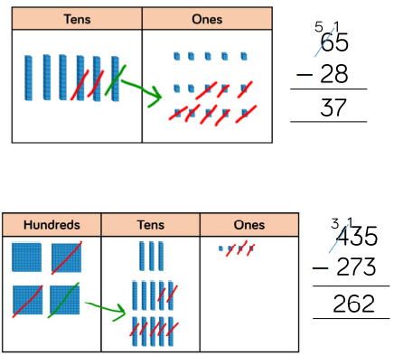  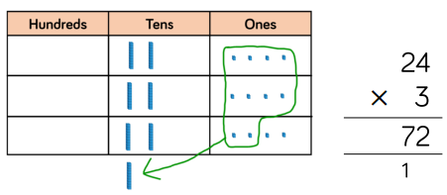  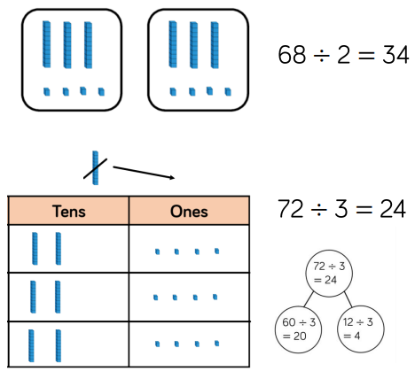
Place Value Counters | Addition  Using place value counters is an effective way to support children’s understanding of column addition. It is important that children write out their calculations alongside using r drawing counters so they can see the clear links between the written method and the model.  Children should first add without an exchange before moving on to addition with exchange. Different place value counters can be used to represent larger numbers or decimals. If you don’t have place value counters, use normal counters on a place value grid to enable children to experience the exchange between columns.  When adding money, children can use the coins to support their understanding. It is important that children consider how the coins link to the written calculation especially when adding decimal amounts.  Subtraction  Using place value counters is an effective way to support children’s understanding of column subtraction. Children should first subtract without an exchange before moving on to subtraction with exchange. If you don’t have place value counters, use normal counters on a place value grid to enable children to experience the exchange between columns.  When building the model, children should just make the minuend using counters, they then subtract the subtrahend. Children start with the smallest place value column. When there are not enough ones/tens/hundreds to subtract in a column, children need to move to the column to the left and exchange e.g. exchange 1 ten for 10 ones. They can the subtract efficiently.  Multiplication  Using place value counters is an effective way to support children’s understanding o column multiplication. Is it important that children write out their calculation alongside the equipment so they can see how the concrete and written match together.  As numbers become larger in multiplication or the amounts of groups becomes higher, Base 10 becomes less efficient due to the amount of equipment and number of exchanges needed. The counters should be used to support the understanding of the written method rather than support the arithmetic.  Place value counters also support the grid method of multiplication well. Children can see how to multiply 2-digit numbers by 2-digit numbers.  Division  Using place value counters is an effective way to support children’s understanding of division.  When working with smaller numbers, children can use place value counters to share between groups. They start by sharing the larger place value column and work from left to right. If there are any counters left over once they have been shared, they exchange the counter e.g. exchange one ten for ten ones. This method can be linked to the part-whole model to support children to show their thinking.  Place value counters also support children’s understanding of short division by grouping the counters rather than sharing them. Children work from left to right through the place value columns and group the counters in the number they are dividing by. If there are any counters left over after they have been grouped, they exchange the counter e.g. exchange one hundred for ten tens. | 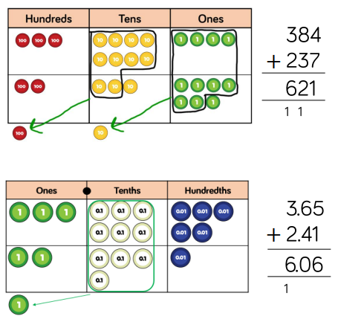  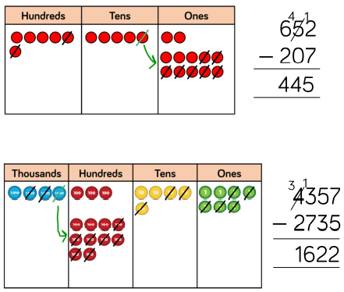  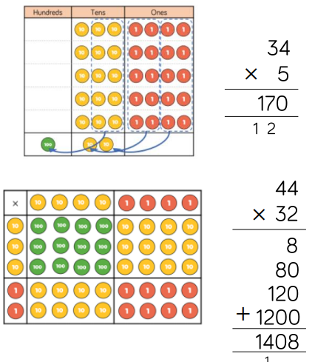  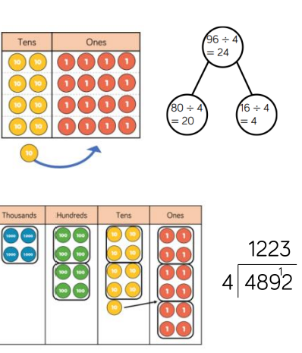

Addition
Key Language: sum, total, parts and wholes, plus, add, altogether, more, ‘is equal to’ ‘is the same as’

Year 3  Skill: Add numbers with up to 3-digits  Base 10 and place value counters are the most effective manipulatives when adding numbers with up to 3-digits.  Ensure children write out their calculation alongside any concrete resources so they can see the links to the written column method.  Plain counters on a place value grid can also be used to support learning. | 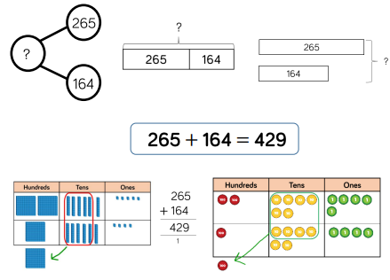
Year 4  Skill: Add numbers with up to 4-digits  Base 10 and place value counters are the most effective manipulatives when adding numbers with up to 4-digits.  Ensure children write out their calculation alongside any concrete resources so they can see the links to the written column method.  Plain counters on a place value grid can also be used to support learning. | 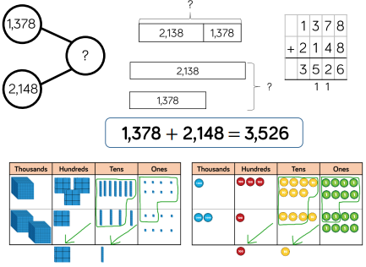
Year 5/6  Skill: Add numbers with more than 4-digits  Place value counters or plain counters on a place value grid ae the most effective concrete resources when adding numbers with more than 4-digits.  At this stage, children should be encouraged to work in the abstract, using the column method to add larger numbers effectively.  Skill: Add with up to 3 decimal places  Place value counters or plain counters on a place value grid ae the most effective manipulatives when adding decimals with 1 2 and then 3 decimal places.  Ensure children have experience of adding decimals with a variety of decimal places. This includes putting this into context when adding money and other measures. |  | 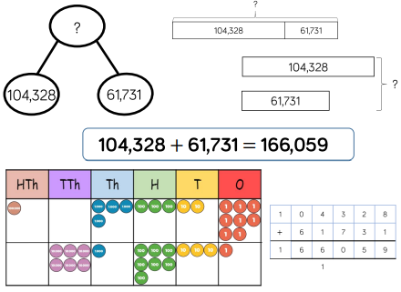
 |  | 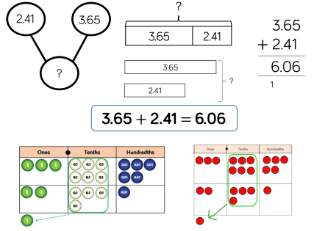

Subtraction
Key Language: sum, total, parts and wholes, plus, add, altogether, more, ‘is equal to’ ‘is the same as’

Year 3  Skill: Subtract numbers with up to 3-digits  Base 10 and place value counters are the most effective manipulative when subtracting numbers with up to 3-digits.  Ensure children write out their calculation alongside any concrete resources so they can see the links to the written column method.  Plain counters on a place value grid can also be used to support learning. | 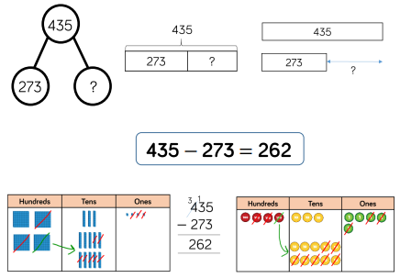
Year 4  Skill: Subtract numbers with up to 4-digits  Base 10 and place value counters are the most effective manipulative when subtracting numbers with up to 4-digits.  Ensure children write out their calculation alongside any concrete resources so they can see the links to the written column method.  Plain counters on a place value grid can also be used to support learning. | 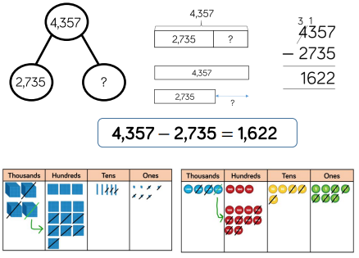
Year 5/6  Skill: Subtract numbers with more than 4-digits  Place value counters or plain counters on a place value grid are the most effective concrete resource when subtracting numbers with more than 4-digits.  At this stage, children should be encouraged to work in the abstract, using column method to subtract larger numbers efficiently.  Skill: Subtract numbers with up to 3 decimal places  Place value counters or plain counters on a place value grid are the most effective manipulative when subtracting decimals with 1, 2 and then 3 decimal places.  Ensure children have experience of subtracting decimals with a variety of decimal places. This includes putting this into context when subtracting money and other measures. | 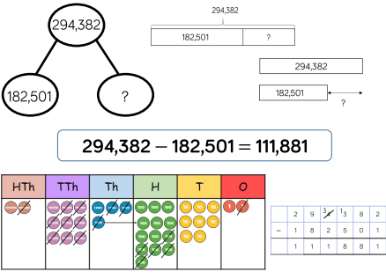
 | 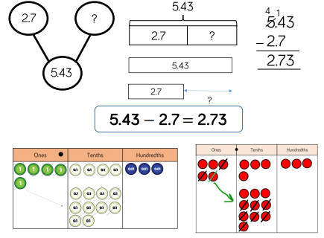

Multiplication
Key Language: multiply, factor, multiple, product, times, area

Year 3/4  Skill: Multiply 2-digit numbers by 1-digit numbers  Teachers may decide to first look at the expanded column method (with chunking) before moving on to the short multiplication method. The place value counters should be used to support the understanding of the method rather than supporting the multiplication, as children should use times table knowledge.  Skill: Multiply 3-digit numbers by 1-digit numbers  When moving onto 3-digit by 1-digit multiplication, encourage children to move towards the short formal written method. Base 10 and place value counters continue to support the understanding of the written method. Limit the number of exchanges needed in the questions and move children away from resources when multiplying larger numbers. | 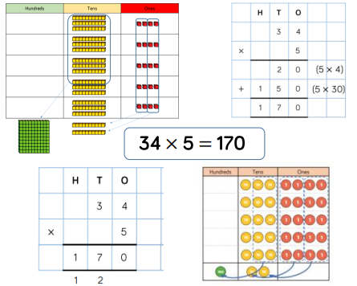  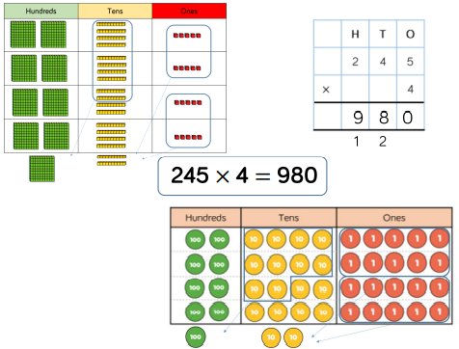
Year 5  Skill: Multiply 4-digit numbers by 1-digit numbers  When multiplying 4-digit numbers, place value counters are the best manipulative to use to support children in their understanding of the formal written method. If children are multiplying larger numbers and struggling with their times tables, encourage the use of multiplication grids so children can focus on the use of the written method (short multiplication).  Skill: Multiply 2-digit numbers by 2-digit numbers  When multiplying a multi-digit numbers by 2-digits use the grid method to help children understand the size of the numbers they are using. This links to finding the area of a rectangle b finding the space covered by the Base 10. The grid method is the initial method of multiplication before moving onto the formal column method (long multiplication).  Skill: Multiply 3-digit numbers by 2-digit numbers  Children can continue to use the grid method when multiplying 3-digits by 2-digits. Place value counters become more efficient to use but Base 10 can be used to highlight the size of numbers. Encourage children to move towards the formal written method of long multiplication linking it back to the grid method if needed. | 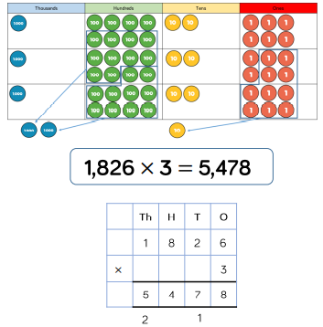
Year 5/6
Skill: Multiply 4-digit numbers by 2-digit numbers

When multiplying 4-digits by 2-digits, children should be confident in the written method. If they are still struggling with times tables, provide multiplication grids to support when they are focusing on the use of the method. Consider where exchanged digits are placed and make sure this is consistent.
Division
Key Language: = divide, partitioned, split equally, shared

Year 3/4  Skill: Divide 2-digits by 1-digit (sharing with exchange)  When dividing numbers involving an exchange, children can use Base 10 and place value counters to exchange one ten for ten ones. Children should start with the equipment outside the place value grid before sharing the tens and ones equally between rows. Flexible partitioning in a part-whole model supports this method.  Skill: Divide 2-digits by 1-digit (sharing with remainders)  When dividing numbers with remainders, children can use Base 10 and place value counters to exchange one ten for ten ones. Starting with the equipment outside the place value grid will highlight remainders, as they will be left outside the grid once the equal groups have been made. Flexible partitioning in a part-whole model supports this method. | 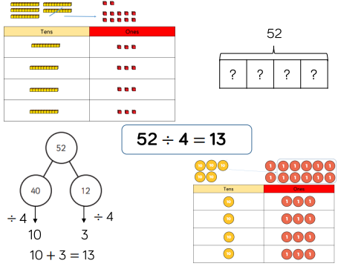  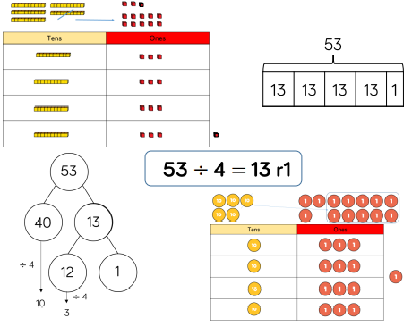
Year 4  Skill: Divide 3-digits by 1-digit (sharing)  Children can continue to use place value counters to share 3-digit numbers into equal groups. Children should start with the equipment outside the place value grid before sharing the hundreds, tens and ones equally between the rows. This method can also help to highlight remainders. Flexible partitioning in a part-whole model supports this method. | 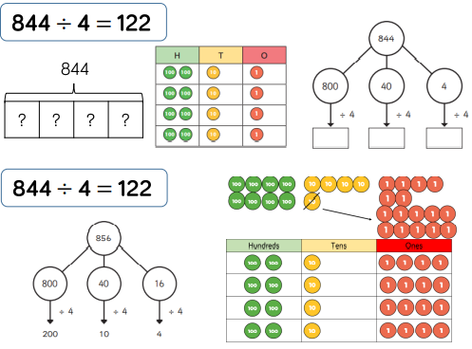
Year 4/5  Skill: Divide 3-digits by 1-digit (grouping)  When using the short division (bus stop method), children use grouping. Stating with the largest place value, they group by the divisor. Language is important here. Children should consider ‘How many groups of 4 tens can we male?’ and ‘How many groups of 4 ones can we make?’.  Remainders can also be seen as they are left ungrouped. | 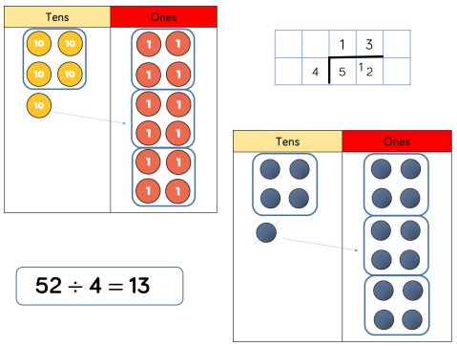
Year 5  Skill: Divide 3-digits by 1-digit (grouping)  Children can continue to use grouping to support their understanding of short division (bus stop method) when dividing a 3-digt number by a 1-digit number. Place value counters can be used on a place value grid to support their understanding. Children can also draw their own counters and group them through a more pictorial method.  Skill: Divide 4-digits by 1-digit (grouping)  Place value counters can be used on a place value grid to support children to divide 4-digits by 1-digit. Children can also draw their own counters and group them through a more pictorial method. Children should be encouraged to move away from the concrete and pictorial model when dividing numbers with exchanges. Short division should be encouraged (bus stop method). | 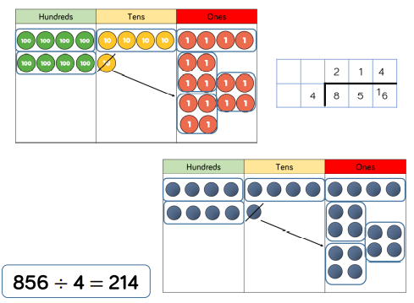  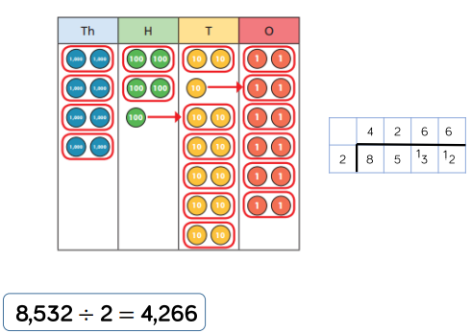
Year 6  Skill: Divide multi-digits by 2-digits (short division)  When children begin to divide up to 4-digits by 2-digits, written methods become the most accurate as concrete and pictorial representations become less effective. Children can write out multiples to support their calculations with larger remainders. Children will also solve problems with remainders where the quotient (result of the division) can be rounded as appropriate.  Skill: Divide multi-digits by 2-digits (long division)  Children can also divide by 2-digit numbers using long division. Children can write out multiples to support their calculations with larger remainders. Children will solve problems with remainders where the quotient can be rounded as appropriate.  When a remainder is left at the end of a calculation, children can either leave it as a remainder or convert it to a fraction. This will depend on the context of the question. Children can also answer questions where the quotient (result of the division) needs to be rounded according to the context. | 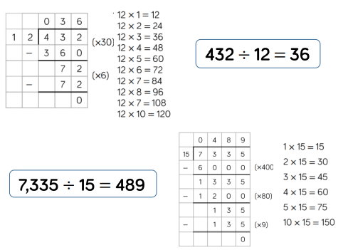  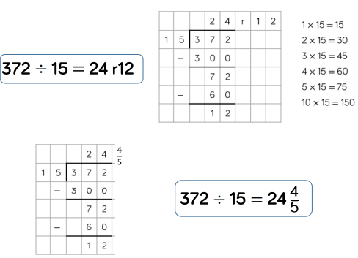

Mathematical Language Glossary:
- Aggregation – combining two or more quantities or measures to find a total.
- Augmentation – increasing a quantity or measure by another quantity.
- Commutative – numbers can be added in any order.
- Difference – the numerical difference between two numbers is found by comparing the quantity in each group.
- Exchange – change a number or expression for another of an equal value.
- Minuend – a quantity or number from which another is subtracted.
- Partitioning – splitting a number into its component parts.
- Subtrahend – a number to be subtracted from another.
- Sum – the result of an addition.
- Array – An ordered collection of counters, cubes or other item in rows and columns.
- Commutative – Numbers can be multiplied in any order.
- Dividend – In division the number that is divided.
- Divisor – In division the number by which another is divided.
- Exchange – Change a number or expression for another of an equal value.
- Factor – A number that multiplies with another to make a product.
- Product – The result of multiplying one number by another.
- Quotient – The result of a division.
- Remainder – The amount left over after a division when the divisor is not a factor of the dividend.
- Scaling – Enlarging or reducing a number by a given amount.

