How does the human body work?
Subject Area: Science
You have already learnt:
Vocabulary
Key words | healthy | 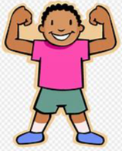 | In a good physical and mental condition.
 | nutrients | 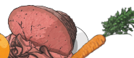 | Things that living things need to stay alive and healthy.
 | energy | 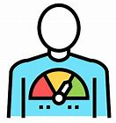 | Strength to be able to move and grow.
 | muscles | 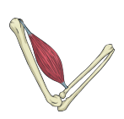 | Soft tissues in the body that contract and relax to cause movement.
 | joints |  | Areas where two or more bones fit together.
Sparkle Words | tendons |  | Cords that join muscles to bones
 | vertebrates | 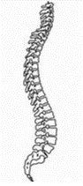 | Animals with backbones
 | invertebrates |  | Animals without backbones
 | endoskeleton | 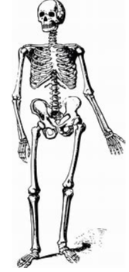 | A skeleton on the inside of the body
 | exoskeleton | 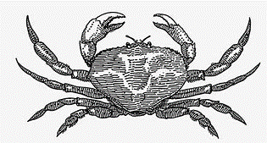 | A skeleton on the outside of the body that supports and protects it.

- What humans and animals need to stay alive.
- What plants need to live healthily.
- To name parts of humans and animals.
Key Learning
• Animals, including humans, need food, water and air to stay alive.
• Living things need food to grow and to be strong and healthy.
• Plants can make their own food, but animals cannot.
• Skeletons do three important jobs:
- protect organs inside the body;
- allow movement;
- support the body and stop it from falling on the floor.

Key Skills
- Ask questions - enquire
- Identify and classify (sort)
- Observe – look closely

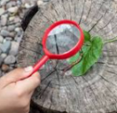
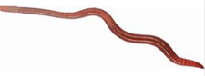

This learning will help me to
- Keep my own body healthy and active.
- Identify parts of the human body.

