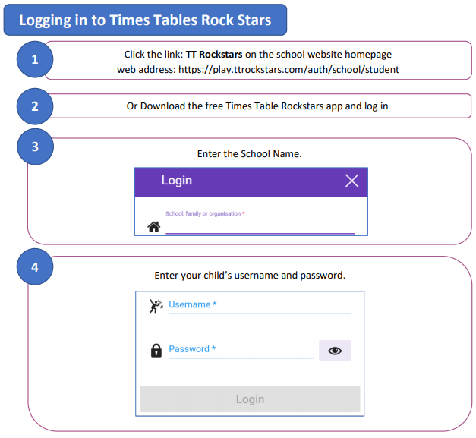

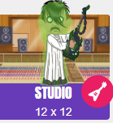
The Studio allows children to practice questions at random from 1×1 up to 12×12 and best manipulates the official Multiplication Tables Check. TT Rock Stars calculates the mean response time from their last 10 games in the Studio and translates that time into a Rock Status.

