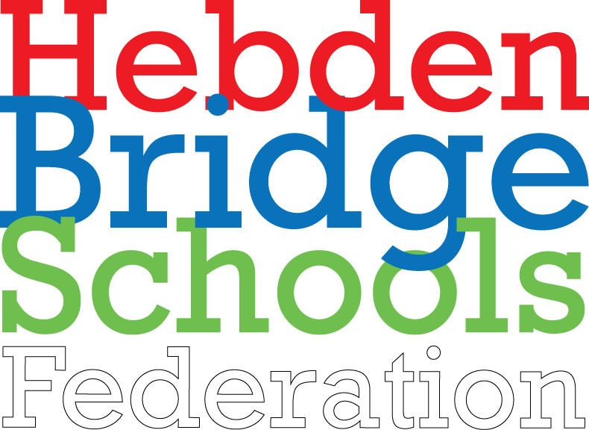

What are the stages of SEND?
Where children are identified as having special educational needs, they will follow a progressive system that aims to provide the best support for the child’s need:
Quality First Teaching
At Riverside Junior School, high quality, inclusive teaching, monitoring and assessment is evident in every classroom.
SEND Concern
Where pupils are displaying gaps in learning or are progressing at a slower pace, every attempt will be made by a class teacher to ensure that the needs of these pupils are met through differentiated learning and carefully planning programmes of intervention.
A SEND initial concern form will be completed and discussed with the SENDCO. The SENDCO may undertake some further observations and assessment of the pupil.
Additional Support
However, in some instances, some pupils require support that is additional or different to the quality first teaching taking place in the classroom. School run a number of provisions that support all four areas of need. These intervention groups are led by specialist teachers, highly training support staff and external services.
Provision and progress for pupils at Additional Support Level will be outlined on a One Page Profile
SEND Support
For some children whose needs cannot be directly met through quality first teaching, a more targeted approach involving parents, school, the child and external services is needed.
These children will be placed on a Individual Education Plan and termly meetings will take place to discuss the outcomes, provision and progress across all areas of SEND relevant to the child.
Education, Health and Care Plans (EHCP)
Where educational progress continues to be limited, despite the support provided by school and external professionals, a request for a statutory assessment of the needs of the child may be sought from the Local Authority.
It may be that an Education, Health and Care Plan (EHCP) is necessary to support the pupil's academic progress and personal development. An Education, Health and Care plan (EHCP) is a legal document which describes a child or young person’s aged up to 25 special educational needs, the support they need, and the outcomes they would like to achieve.
The EHCP is reviewed annually and reported to the Local Authority.

